RRN

CONTINUOUS ASSESSMENT TEST - 1
OCTOBER / NOVEMBER 2025

Programme & Branch | : | B.Tech AI & ML
Semester | : | I | Date & Session | : | 27/10/2025 & AN
Course Code & Name | : | MAE 1161-Mathematics for Computer Science
Duration | : | 90 minutes | Maximum Marks | : | 50

ANSWER ALL QUESTIONS
PART A (5 X 2 = 10 MARKS) |  |  |  | CO | KL
 |  | Convert 77₈ to its binary equivalent. |  | CO1 | KL3
 |  | State the uses of Cayley Hamilton Theorem. |  | CO2 | KL1
 |  | If relation G = {7, 8} and relation H = {5, 4, 2}, determine the relation G×H and relation H×G. |  | CO1 | KL5
 |  | A 3 x 3 matrix A has two of its eigenvalues as 3 and 6. If the trace is 11. Find the eigenvalues of A⁻¹. |  | CO2 | KL2
 |  | Define reflection transformation. Explain with an example |  | CO2 | KL2
PART B (2 X 16 = 32 MARKS) |  |  |  | CO | KL
6. a | (i) | Convert (325)₁₀ to binary, octal, and hexadecimal with full steps. | (8) | CO1 | KL1
 | (ii) | Let A ={1,2,3,4}.Consider the relation R defined on A:R={(1,1),(2,2),(3,3),(4,4),(1,3),(3,1),(2,4),(4,2)} verify whether R is transitive, symmetric, and reflexive. | (8) | CO1 | KL4
(OR)
b | (i) | Using modular exponentiation, find 5⁷⁵ mod13. Show all intermediate steps using successive squaring. | (8) | CO1 | KL3
 | (ii) | Determine the remainder when 3¹⁰⁰ is divided by 7. | (8) | CO1 | KL3
7.a |  | Find A⁻¹ for matrix A using the Cayley Hamilton Theorem  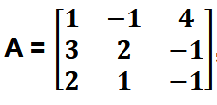 | (16) | CO2 | KL3
(OR)
b | (i) | Find the characteristic equation for the matrix A and hence find A⁻¹  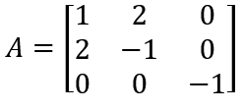 | (8) | CO2 | KL3
 | (ii) | Find the eigenvalues and Eigen Vectors of 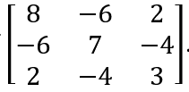 | (8) | CO2 | KL3
PART C (1 X 8 = 8 MARKS) |  |  |  | CO | KL
8. a |  | Let U = {x ∈ N | x ≤ 10}, A = {x ∈ U | x is a divisor of 10} and  B = { x ∈ U ∣ x is an odd number}  C = {x ∈ U | x is a multiple of 3}  i) Express A,B and C in roster form.  ii) Find the set A ∩ (BUC’)  iii) Verify the De Morgan Laws for sets B and C | (8) | CO1 | KL3
(OR)
b | i)  ii) | Using the minor method find the rank of the following matrix  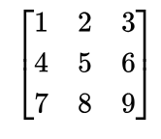  For matrix A  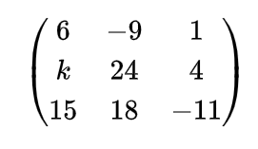  find the value of k for which the rank of A = 2 | (8) | CO2 | KL3
************

